 Year 8 Science 2021

Cell Biology and Microscope Test (M)

Student Name: _______________________________________

Please answer all questions in the spaces provided. You will have 40 minutes to complete the test.

You will need:

· Pencil

· Ruler

· Pen

· Eraser

· Calculator

Final mark: /35

**Part 1: Please circle the most correct answer: (4 marks)**

1. The job of the mitochondria in cells is to

a. repair cell damage

b. store cell waste

c. control the cell’s activities

d. make and release energy

1. On the microscope, the objective lens is found on the

a. eyepiece

b. nosepiece

c. mouthpiece

d. chin piece

1. Tiny structures that carry out cell functions are collectively called:
2. animalcules
3. organelles
4. tissues
5. ribosomes

4) A human cheek cells is best described as

1. a prokaryotic cell
2. an organism
3. a plant cell
4. an animal cell

**Part 2: Label a Cell (8 Marks)**

5) Correctly label the diagram below with the terms (6 Marks)

**Vacuole nucleus cell wall**

**Cell membrane cytoplasm chloroplast.**

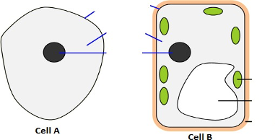

**6) From the diagram in question 5, which cell, A or B, is a plant cell? (2 Marks)**

**Give one reason for your answer**

Answer: _____________________________________________________________________________

Reason: _______________________________________________________________________________________________________________________________________________________________________________________________________________________________________________________________________________________________________________

**7) Photosynthesis (5 Marks)**

Photosynthesis is the way that plants absorb nutrients from the sun. Every plant does it as a way to gain energy and keep growing.

Using the following words, complete the Photosynthesis equation:-

**Sunlight Water Carbon Dioxide**

**Oxygen Glucose**

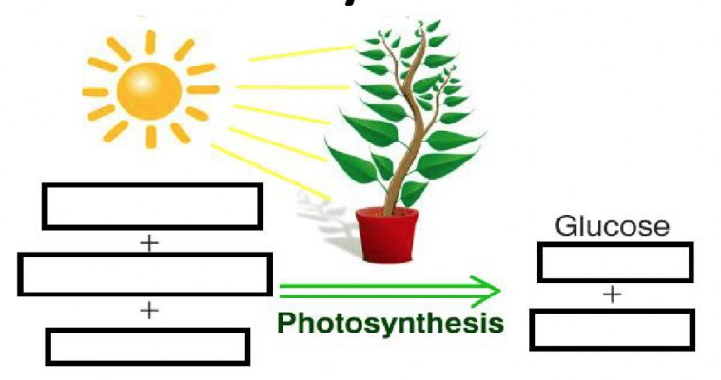



**8) Microscopes (8 Marks)**

Using the names provided in the table, label the microscope below with the correct names.

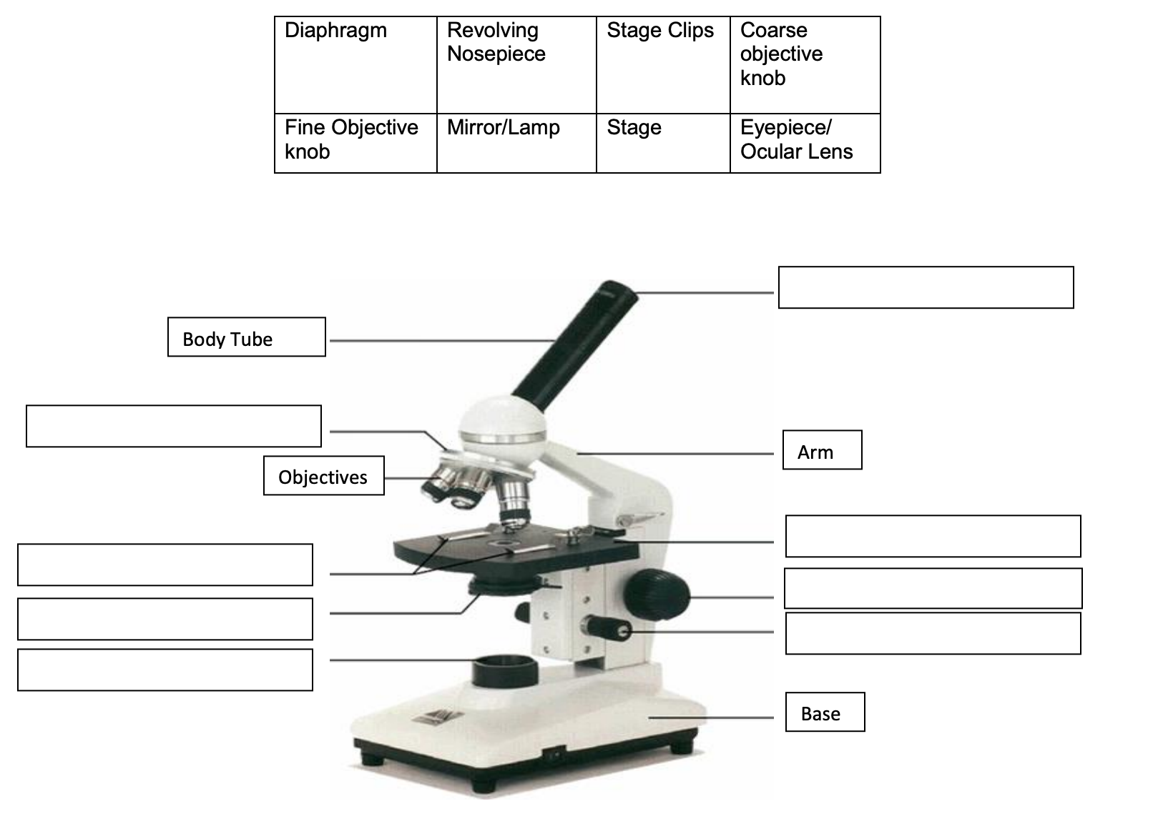

**9. Inside of a Cell: Amusement Park Analogy (10 Marks)**

Floating around in the cytoplasm of a cell are small structures called *organelles*. Like the organs in your body, each one carries out a specific function necessary for the cell to survive.

*For each organelle below, draw what the organelle looks like, list the part of the amusement park that is similar to that organelle and explain why you matched the cell organelle up with that part of the amusement park.*

*Cell membrane Cell Wall Cytoplasm Nucleus*

*Mitochondria Ribosomes Lysosomes*

*Endoplasmic Reticulum Chloroplast Vacuole*

1. **CELL MEMBRANE**:

What part does the **CELL MEMBRANE** resemble in an amusement park? ______________________________________________________________

1. **CELL WALL**:

What part does the **CELL WALL** resemble in an amusement park? ______________________________________________________________

The Cell membrane is different to the cell wall because __________________________________________________________________________________________________________________________________________________________________________________________

1. **NUCLEUS**:

What part does the **NUCLEUS** resemble in an amusement park? _____________________________________________________________

1. **ENDOPLASMIC RETICULUM**:

What part does the **E.R.** resemble in an amusement park? ______________________________________________________________

I chose this to represent the **E.R.** because_________________________________________________________________________________________________________________________________________________________________________________________________________________________________________________

1. **MITOCHONDRIA**:

What part does the **MITOCHONDRIA** resemble in an amusement park? ______________________________________________________________

I chose this to represent the **MITOCHONDRIA** because_________________________________________________________________________________________________________________________________________________________________________________________________________________________________________________

1. **RIBOSOMES**:

What part do the **RIBOSOMES** resemble in an amusement park?

______________________________________________________________

I chose this to represent the **RIBOSOMES** because___________________________________________________________________________________________________________________________________________________________________________________

1. **CHLOROPLAST**

What part do the **CHLOROPLAST** resemble in an amusement park?

______________________________________________________________

I chose this to represent the **CHLOROPLAST** because___________________________________________________________________________________________________________________________________________________________________________________

**Year 8 Biological Sciences 2020 **

**Practical: Microscope Skills Assessment**

Name: _____________________

**Microscope skills**

|  |  |  |
| --- | --- | --- |
| **Practical skill required** | **Marks achieved** | **Marks available** |
| Slide is in place and centred using stage clips or stage dials |  | 1 |
| Starts on the lowest objective lens possible (usually x4) |  | 1 |
| Use the coarse focus before the fine focus |  | 1 |
| Ability to focus properly |  | 1 |
| Names at least three parts |  | 2 |
| Handles microscope safely and correctly - question |  | 2 |

Total marks: / 8